**********************************************************************************

|  |  |  |  |  |  |  |  |  |  |  |  |  |  |  |  |  |  |  |  |  |  |  |  |  |  |  |  |  |  |  |  |  |  |  |  |  |  |  |  |  |  |  |  |  |  |  |  |  |  |  |  |  |  |  |  |  |  |  |  |  |  |  |  |  |  |  |  |  |  |  |  |  |  |  |  |
| --- | --- | --- | --- | --- | --- | --- | --- | --- | --- | --- | --- | --- | --- | --- | --- | --- | --- | --- | --- | --- | --- | --- | --- | --- | --- | --- | --- | --- | --- | --- | --- | --- | --- | --- | --- | --- | --- | --- | --- | --- | --- | --- | --- | --- | --- | --- | --- | --- | --- | --- | --- | --- | --- | --- | --- | --- | --- | --- | --- | --- | --- | --- | --- | --- | --- | --- | --- | --- | --- | --- | --- | --- | --- | --- | --- |
| Here’s a **comprehensive compatibility matrix** combining **Spring Framework**, **Spring Boot**, **Apache Tomcat**, **Hibernate (JPA)**, and **Java versions**:  **✅ Compatibility Table**   | **Component** | **Version** | **Java Compatibility** | | --- | --- | --- | | **Spring Framework** | 7.0.x (planned) | Java 17 – 27 (expected) | |  | 6.2.x | Java 17 – 25 | |  | 6.1.x | Java 17 – 23 | |  | 6.0.x | Java 17 – 21 | |  | 5.3.x (LTS) | Java 8 – 21 | | **Spring Boot** | 4.0.x | Java 21 – 24 | |  | 3.5.x | Java 17 – 24 | |  | 3.0.x – 3.4.x | Java 17 – 21 | |  | 2.7.x | Java 8 – 21 | | **Apache Tomcat** | 11.0.x | Java 17+ | |  | 10.1.x | Java 11+ | |  | 9.0.x | Java 8+ | |  | 8.5.x | Java 7+ | | **Hibernate ORM** | 6.6.x | Java 11, 17, 21 (JPA 3.2) | |  | 6.0 – 6.5.x | Java 11, 17 (JPA 3.0/3.1) | |  | 5.6.x | Java 8, 11, 17 (JPA 2.2) | |  | 5.4.x | Java 8, 11, 17 (JPA 2.2) | |  | 5.3.x | Java 8, 11 (partial 17 support) | | **JPA Spec** | 3.0 / 3.1 / 3.2 | Jakarta EE 9+ (Java 11+) | |  | 2.2 | Java EE 8 (Java 8+) |   **✅ Key Notes**   * **Spring Boot 3.x** → Requires **Java 17+**, uses **Jakarta EE 9 APIs**, embedded **Tomcat 10.1.x**, and Hibernate **6.x**. * **Spring Boot 2.x** → Supports **Java 8**, uses *javax. APIs*\*, embedded **Tomcat 9.x**, and Hibernate **5.x**. * **Hibernate 6.x** → Implements **JPA 3.x** (Jakarta namespace). * **Hibernate 5.x** → Implements **JPA 2.2** (javax namespace).   Here are the **key features of Spring Framework 5.3.x (LTS)**:  **✅ Core Features**   * **Java 8+ Baseline**   + Full support for **Java 8**, **Java 11**, and **Java 17** (later updates added Java 21 support). * **Java EE 8 Compatibility**   + Uses javax.* namespace (Servlet 4.0, JPA 2.2, Bean Validation 2.0). * **Kotlin Support**   + Enhanced Kotlin DSLs and coroutine support for reactive programming. * **Functional Bean Registration**   + Ability to register beans using functional style (lambda-based configuration).   **✅ Web & Reactive**   * **Spring WebFlux**   + Reactive web framework supporting **Reactor** and **RxJava 2/3**. * **Spring MVC Enhancements**   + Improved support for HTTP/2, WebSocket, and REST APIs. * **RSocket Integration**   + Built-in support for RSocket messaging.   **✅ Testing & Integration**   * **JUnit 5 Support**   + Full integration with JUnit Jupiter. * **MockMvc & WebTestClient**   + Advanced testing for both MVC and WebFlux applications.   **✅ Other Improvements**   * **GraalVM Native Image Support** (experimental) * **Improved Dependency Injection**   + Better support for @Nullable and Kotlin null-safety. * **Jackson 2.12+ Support**   + Updated JSON serialization/deserialization support. * **Groovy 3.0 Support**   + Official support for Groovy 3.x.   **End of Life:**   * Open-source support ended **August 31, 2024**, but commercial support continues for LTS users.   **Spring 5.3.x (LTS) – Final 5th Generation**   * **Java 8+ Baseline**: Supports Java 8, 11, 17, and 21. * **Java EE 8 APIs**: javax.* namespace (Servlet 4.0, JPA 2.2, Bean Validation 2.0). * **Reactive Programming**: Spring WebFlux for non-blocking apps. * **Kotlin Support**: Enhanced DSLs and coroutine support. * **Functional Bean Registration**: Lambda-based bean configuration. * **Testing**: Full JUnit 5 integration, MockMvc, WebTestClient. * **GraalVM Native Image (Experimental)**. * **Observability**: Micrometer integration for metrics. * **End of OSS Support**: Aug 31, 2024 (commercial support continues).   1  **✅ Spring 6.x (6.0, 6.1, 6.2) – 6th Generation**   * **Java 17 Minimum**: Full alignment with modern JDKs. * **Jakarta EE 9+**: Migration from javax.* → jakarta.* (Servlet 5.0+, JPA 3.0+). * **Improved AOT & Native Support**: GraalVM reachability metadata. * **HTTP/2 & WebSocket Enhancements**. * **RestClient & JdbcClient**: Modern APIs for HTTP and DB access. * **Observability**: Micrometer 2.x, OpenTelemetry integration. * **Security & Cloud-Native**: Stronger integration with Spring Security and Kubernetes. * **Baseline for Spring Boot 3.x**.   1  **✅ Spring 7.0.x (Upcoming Major Release)**   * **Java 17+ Baseline** (Recommended JDK 25). * **Jakarta EE 11**: Servlet 6.1, JPA 3.2, Bean Validation 3.1. * **Null Safety with JSpecify**: Better Kotlin integration. * **API Versioning**: Built-in support for versioned REST endpoints. * **Resilience Features**: @Retryable, @ConcurrencyLimit, @EnableResilientMethods. * **Programmatic Bean Registration**: BeanRegistrar for dynamic beans. * **New Clients**: JmsClient, enhanced JdbcClient, centralized HTTP message converters. * **Streaming HTTP Support**: InputStream/OutputStream for large data. * **Testing**: New RestTestClient for REST API tests. * **Removed Legacy APIs**: XML MVC config deprecated, JUnit 4 support deprecated. * **GraalVM 24 Support**: Unified reachability metadata. * **Jackson 3.x Default** (Jackson 2.x deprecated).   2  3  4  **🔍 Key Evolution**   * **5.x → 6.x**: Migration from Java EE to Jakarta EE, Java 17 baseline, native image readiness. * **6.x → 7.x**: API modernization, resilience, null safety, cloud-native optimizations, and Jakarta EE 11 alignment.   ******************************************************************************  Here’s a **developer-focused summary of Spring Boot features from 4.x (upcoming) to the latest stable versions**:  **✅ Spring Boot 4.x (Upcoming, built on Spring Framework 7)**   * **Java & JVM Support**   + **Minimum JDK:** 17   + **Recommended JDK:** 25   + Full **GraalVM 24** alignment for native image builds. * **Jakarta EE 11 Alignment**   + Servlet 6.1, JPA 3.2 (Hibernate ORM 7.0), Bean Validation 3.1. * **Kotlin 2.2 Support**   + Better coroutine support and Gradle integration. * **Cloud-Native Enhancements**   + Faster **Buildpacks**, efficient Docker-native builds.   + **Micrometer 2.x + OpenTelemetry** for observability. * **Developer Productivity**   + New **Actuator Endpoints**, improved CLI, easier property/profile management. * **Security**   + Based on **Spring Security 7**, stronger OAuth 2.2 / OIDC integration. * **Future-Proofing**   + Initial hooks for **Spring AI** integrations.   + Better APIs for **native image hints**. * **New Features from Spring Framework 7**   + **API Versioning** in @RequestMapping.   + **Null Safety** with JSpecify.   + **Resilience Annotations**: @Retryable, @ConcurrencyLimit.   + **Streaming HTTP Support** for large files.   + **New Clients**: JmsClient, enhanced JdbcClient.   + **RestTestClient** for REST API testing.   + **Centralized HTTP Message Converter Config**.   + **XML Config Deprecated**, JUnit 4 support removed.   1  **✅ Spring Boot 3.x (Current Major Release)**   * **Java 17+ Required** (Java 21 recommended). * **Migration to Jakarta EE 10** (from javax.* → jakarta.*). * **Embedded Tomcat 10.1.x**, Jetty 11, Undertow 2.3. * **Hibernate 6.x** (JPA 3.0). * **Improved AOT & Native Image Support** (GraalVM). * **Observability**: Micrometer 2.x, OpenTelemetry. * **New APIs**: RestClient, JdbcClient. * **Removed Legacy**: Deprecated starters, older JDK support.   **✅ Spring Boot 2.x (Legacy)**   * **Java 8 – 17 Support**. * **Jakarta EE 8 / Java EE APIs** (javax.*). * **Embedded Tomcat 9.x**. * **Hibernate 5.x** (JPA 2.2). * **Actuator**, **DevTools**, and **Auto-Configuration** were core features. * **End of OSS Support**: 2.7.x is the last line, now in maintenance.   **🔍 Key Evolution**   * **2.x → 3.x**: Big migration to Jakarta EE 10, Java 17 baseline, native image readiness. * **3.x → 4.x**: Jakarta EE 11, JDK 25 readiness, resilience patterns, API versioning, AI hooks.   ******************************************************************************  Here’s a **developer-focused summary of Apache Tomcat features across major versions up to the latest**:  **✅ Tomcat 8.5.x**   * **Java EE 7 Support**: Servlet 3.1, JSP 2.3, EL 3.0, WebSocket 1.1. * **HTTP/2 Support** (with APR/native connector). * **Improved Performance**: Async I/O enhancements. * **Security**: TLS improvements, stronger defaults. * **Java Compatibility**: Java 7+, commonly used with Spring Boot 1.x and 2.x.   **✅ Tomcat 9.0.x**   * **Java EE 8 Support**: Servlet 4.0 (HTTP/2 core support), JSP 2.3, EL 3.0. * **HTTP/2 Push**: Server push for better performance. * **Enhanced WebSocket**: Full compliance with JSR 356. * **Improved Startup Time**: Optimized class scanning. * **Java Compatibility**: Java 8+, widely used with Spring Boot 2.x.   **✅ Tomcat 10.1.x**   * **Jakarta EE 9 Support**: Migration from javax.* → jakarta.*. * **Servlet 5.0**, JSP 3.0, EL 4.0, WebSocket 2.0. * **HTTP/2 and ALPN**: Better TLS/HTTP2 integration. * **Java Compatibility**: Java 11+, used with Spring Boot 3.x.   **✅ Tomcat 11.0.x (Latest)**   * **Jakarta EE 11 Support**: Servlet 6.1, JSP 4.0, EL 6.0, WebSocket 2.2. * **Modern Protocols**: HTTP/3 (QUIC) experimental support. * **Security Hardening**: Stronger defaults, OpenSSL integration. * **Performance**: Optimized for high concurrency and cloud-native deployments. * **Java Compatibility**: Java 17+, aligns with Spring Boot 4.x.   **🔍 Key Evolution for Developers**   * **Namespace Migration**: javax.* → jakarta.* (Tomcat 10+). * **HTTP/2 & HTTP/3**: Better performance for modern web apps. * **Cloud-Native**: Container-friendly, faster startup, TLS improvements. * **Spring Boot Mapping**:   + Boot 2.x → Tomcat 9.x   + Boot 3.x → Tomcat 10.1.x   + Boot 4.x → Tomcat 11.x   ******************************************************************************  Here’s a **developer-focused summary of Hibernate ORM (JPA) features version-wise**:  **✅ Hibernate ORM 5.x (JPA 2.2)**   * **Java 8 Support**: Full support for Java 8 date/time API (JSR 310). * **Bootstrap API**: Programmatic bootstrapping without persistence.xml. * **Improved Criteria API**: Better handling of literals and constants. * **Hibernate Search**: Full-text search with Lucene/Elasticsearch integration. * **Hibernate Validator**: Built-in validation annotations (@Email, @NotBlank, etc.). * **Bytecode Enhancement**:   + Lazy loading for fields.   + Dirty checking.   + Automatic bidirectional association sync. * **Multi-Entity Loading**: Load multiple entities by ID in one call. * **Support for JCache**: Second-level caching with JCache API. * **Spatial Support**: GIS data handling via Hibernate Spatial. * **Improved JPQL/HQL**: Join unrelated entities, better parsing. * **Removed Javassist** (in 5.6): Byte Buddy is now the default for bytecode enhancement.   1  2  **✅ Hibernate ORM 6.x (JPA 3.0 / 3.1)**   * **Jakarta EE 9+ Migration**: javax.persistence → jakarta.persistence. * **Java 11+ Baseline**: Optimized for Java 11, 17, and 21. * **New Query Engine**:   + Faster HQL/JPQL parsing.   + Better SQL generation. * **Improved Bootstrapping**: Simplified configuration and SessionFactory creation. * **Enhanced Type System**: Better mapping for arrays, enums, and custom types. * **Soft Delete Support**: Built-in support for soft deletes. * **Array Functions**: Native array handling in queries. * **Non-String Tenant IDs**: Multi-tenancy improvements. * **Jakarta Data Integration**: Early support for Jakarta Data API. * **Performance**: Reduced memory footprint and faster query execution.   3  4  **✅ Hibernate ORM 7.x (JPA 3.2)**   * **Jakarta EE 11 Alignment**: Servlet 6.1, JPA 3.2, Bean Validation 3.1. * **Java 17+ Baseline**: Optimized for JDK 17, 21, and 23. * **Resource Scanning Improvements**: Faster startup and classpath scanning. * **Locking Enhancements**: Better concurrency control. * **@ConcreteProxy Annotation**: For advanced proxy handling. * **Embeddable Inheritance**: More flexible entity modeling. * **Extended Array Support**: Advanced array mapping and functions. * **Native Query Enhancements**: Better integration with modern SQL features. * **Improved Observability**: Metrics and tracing hooks for Micrometer/OpenTelemetry. * **Future-Oriented**: Prepares for Jakarta Data and cloud-native persistence.   3  4  **🔍 Key Evolution**   * **5.x → 6.x**: Migration to Jakarta EE, new query engine, better type system. * **6.x → 7.x**: Performance tuning, advanced mapping, Jakarta EE 11 compliance.   *****************************************************************************  Here’s a **developer-focused comparison of JPA features vs Hibernate ORM features version-wise**:  **✅ JPA vs Hibernate: Version Mapping**   | **JPA Version** | **Hibernate Version** | **Namespace** | | --- | --- | --- | | JPA 2.2 | Hibernate 5.x | javax.persistence.* | | JPA 3.0 / 3.1 | Hibernate 6.x | jakarta.persistence.* | | JPA 3.2 | Hibernate 7.x | jakarta.persistence.* |   **✅ JPA Features (Specification)**   * **JPA 2.2 (Java EE 8)**   + Java 8 Date/Time API support (LocalDate, Instant).   + Stream API for queries.   + Repeatable annotations.   + CDI integration improvements. * **JPA 3.0 (Jakarta EE 9)**   + Namespace change: javax.* → jakarta.*.   + No major functional changes (migration release). * **JPA 3.1 (Jakarta EE 10)**   + Minor clarifications and bug fixes. * **JPA 3.2 (Jakarta EE 11)**   + Planned improvements for better integration with Jakarta Data and cloud-native persistence.   **✅ Hibernate Features Beyond JPA**  Hibernate is a JPA provider but adds **extra capabilities**:   * **Advanced Caching**: Second-level cache, query cache. * **Custom Types**: User-defined types, JSON mapping. * **Batch Processing**: Multi-entity loading, batch inserts/updates. * **Enhanced Fetching**: Fetch profiles, entity graphs. * **Hibernate Search**: Full-text search with Lucene/Elasticsearch. * **Multi-Tenancy**: Database-level, schema-level, and discriminator-based. * **Bytecode Enhancement**: Lazy loading, dirty checking. * **Native SQL Support**: Advanced SQL functions and dialects. * **Schema Management**: Automatic schema generation and validation. * **Integration**: With Spring, Micrometer, and GraalVM native images.   **🔍 Key Difference**   * **JPA** = Standard API (portable, vendor-neutral). * **Hibernate** = JPA implementation + extra features for performance, flexibility, and advanced use cases.   ****************************************************************************  Below is a **developer-focused, version‑by‑version timeline** of the main HTTP clients you’ll encounter in the Spring ecosystem—**RestTemplate**, **WebClient**, **OpenFeign**, **Apache HttpClient**, plus the **newer Spring clients** (**RestClient** and **HTTP Interfaces**). I’ve included what they do, when they arrived, how they evolved, and their current status.  **Quick recommendation (2025)**   * **Synchronous** calls, modern API: **RestClient (Spring 6.1+)** → preferred over RestTemplate for new code.   1   * **Asynchronous / Reactive / Streaming**: **WebClient (Spring 5+)**.   2   * **Declarative clients (interfaces)**: **HTTP Interfaces @HttpExchange (Spring 6+)** or **Spring Cloud OpenFeign** (microservices with service discovery & load‑balancing).   3  4   * **Underlying HTTP engines**: **JDK java.net.http.HttpClient (Java 11+)** or **Apache HttpClient 5.x** (HTTP/2, async).   5  6  **1) RestTemplate — the original synchronous client (Spring 3.0 → now)**  **What it is:** A synchronous, template‑style HTTP client. **Introduced in Spring 3.0** (Since: 3.0 in the Javadocs).  7  **Highlights over time**   * **Spring 3.x–4.x:** Classic getForObject, postForEntity, exchange, error handlers, interceptors, and pluggable message converters. **Backed by multiple HTTP engines** (JDK HttpURLConnection, Apache HttpComponents, etc.).   7   * **Spring 5.0:** Marked **“maintenance mode”**—no big new features planned; the team recommends **WebClient** for async/streaming and modern needs.   2   * **Spring 6.1:** The Javadoc explicitly points devs to the **new RestClient** for a modern synchronous API while keeping RestTemplate supported.   7  **Status today:** Supported, but **no longer evolving**; prefer **RestClient** for new synchronous code.  7  **2) WebClient — reactive/non‑blocking (Spring 5.0+)**  **What it is:** Reactive HTTP client introduced with WebFlux in **Spring 5**; supports **async, streaming, and can be “blocked” for sync** when needed. Works on servlet or reactive runtimes.  2  8  **Key features & enhancements**   * **Non‑blocking I/O** with Reactor types (Mono/Flux), request filters, codecs, backpressure.   8   * **Modern alternative to RestTemplate** for scenarios needing async/streaming; the official docs call it out explicitly.   2   * **Continuous improvements** across 5.x → 6.x (e.g., better codecs and configuration). (See WebClient section of the official reference.)   2  **Status today:** **Primary client** for reactive or streaming use cases.  2  **3) RestClient — the modern synchronous API (Spring 6.1+)**  **What it is:** A **fluent, synchronous** HTTP client designed to feel like WebClient but **without Reactor**, built atop the same infrastructure (request factories, interceptors, converters). **Introduced in Spring Framework 6.1**.  1  **Key features**   * Fluent builder (create, builder) with get()/post().retrieve().body(...) style. * Can **reuse a RestTemplate’s configuration** (RestClient.create(RestTemplate)), easing migration.   1   * Runs over different engines (JDK HttpClient, Apache HttpComponents).   1  **Status today:** **Recommended synchronous client** going forward.  1  **4) Declarative HTTP Interfaces — @HttpExchange & friends (Spring 6.0+; more in Spring 7 / Boot 4)**  **What it is:** **Interface‑driven, declarative HTTP clients** baked into Spring (think “Feign‑like”) using @HttpExchange, @GetExchange, etc. Create an interface, annotate methods, and Spring generates a proxy via HttpServiceProxyFactory. **Introduced in Spring 6.0**, expanded in **Spring 7**.  3  9  **Recent enhancements**   * **Grouping & autowiring** of multiple clients via **@ImportHttpServices** (Spring 7), plus a dedicated **@HttpServiceClient** for smoother Boot integration.   10  11  9   * **Spring Boot 4.0.0‑M2** adds first‑class support for @HttpServiceClient.   12  **Status today:** Great for **declarative clients** entirely inside Spring (no extra library), evolving further in Spring 7 / Boot 4.  10  12  **5) OpenFeign (Spring Cloud OpenFeign) — declarative client with Cloud integration**  **What it is:** A **declarative REST client** where you define Java interfaces annotated with Spring MVC or Feign annotations; Spring generates implementations. Integrates with **service discovery** and **load‑balancing** (Eureka, Spring Cloud LoadBalancer) and works nicely in microservice setups.  4  **Key features**   * Pluggable **encoders/decoders** and **HTTP message converters**. * Support for **circuit breakers** (via Spring Cloud CircuitBreaker), **load‑balancing** (via Spring Cloud LoadBalancer), and **@FeignClient** fallbacks.   4  13  **Status today:** Still a solid choice in **Spring Cloud** microservice stacks; if you’re not on Spring Cloud, consider Spring’s **HTTP Interfaces**.  4  **6) Underlying HTTP engines you’ll meet**  **a) Apache HttpClient (4.x → 5.x)**   * **HttpClient 5** adds **HTTP/2** and modern **async** APIs with an event‑driven model; there’s also an **HTTP/2‑optimized async client** supporting multiplexing over a single connection.   6  14   * Often used as the **engine** under RestTemplate/RestClient/WebClient via Spring’s request factories. (RestTemplate Javadoc mentions Apache HttpComponents explicitly.)   7  **b) JDK java.net.http.HttpClient (Java 11+)**   * **Standard** in Java 11: supports **HTTP/1.1 & HTTP/2**, **synchronous and asynchronous** calls (CompletableFuture), and **WebSocket**. Builder‑based and immutable.   5  15  **Note:** Spring Framework 7 removes built‑in **OkHttp3** support; prefer JDK HttpClient or Apache HttpClient going forward.  10  **Feature timeline (high‑level)**   * **2009–2016 (Spring 3–4):** RestTemplate becomes the go‑to synchronous client; supports interceptors, error handlers, message converters, and multiple HTTP engines.   7   * **2017 (Spring 5.0):** WebClient arrives with WebFlux for non‑blocking I/O and streaming; docs position it as the modern alternative for reactive needs; RestTemplate enters **maintenance mode**.   2   * **2018–2021:** WebClient matures; **Java 11** lands with the new standard **HttpClient** API (HTTP/2, WebSocket); many teams start using it under Spring’s clients.   5   * **2022–2023 (Spring 6.x / Boot 3.x):**   + **Jakarta** migration (javax → jakarta) across the stack.   + **HTTP Interfaces** with @HttpExchange deliver first‑party declarative clients in Spring.   3   * + **RestClient (6.1)**: fluent synchronous alternative to RestTemplate.   1   * **2025 (Spring 7 / Boot 4 milestones):**   + Declarative clients get **@HttpServiceClient** and **@ImportHttpServices** for easier discovery and configuration; **OkHttp3 support removed**; recommended JDKs and Jakarta EE 11 baselines.   11  10  **Which one should you use now?**   * **Blocking, simple API, no Reactor:** **RestClient**. If you’re on RestTemplate, migrate incrementally—RestClient.create(restTemplate) lets you reuse configuration.   1   * **Reactive/async/streaming:** **WebClient**.   2   * **Declarative interfaces:**   + **Inside Spring (no Spring Cloud):** **HTTP Interfaces** with @HttpExchange, and for Boot 4: @HttpServiceClient + @ImportHttpServices.   3  12  9   * + **Spring Cloud microservices:** **OpenFeign**.   4   * **Engine choice:** JDK **HttpClient** (built‑in, HTTP/2, WebSocket) or **Apache HttpClient 5** (feature‑rich, HTTP/2, advanced async). |

********************************************************************************

Here is a **complete version-wise list of Java features and enhancements** from **Java 1.0 to Java 24**, focused on what developers gained in each release

**🔹 Java 1.0 (1996)**

* Object-Oriented Programming (OOP)
* Platform Independence
* Automatic Garbage Collection
* Thread support
* Applets

**🔹 Java 1.1 (1997)**

* Inner Classes
* JavaBeans
* JDBC
* Reflection API
* RMI

**🔹 Java 1.2 (1998) – Java 2**

* Swing API
* Collections Framework
* JIT Compiler
* Java Plug-in
* Security Model improvements

**🔹 Java 1.3 (2000)**

* HotSpot JVM
* RMI over IIOP
* JavaSound API

**🔹 Java 1.4 (2002)**

* assert keyword
* Regular Expressions
* Exception Chaining
* NIO (New I/O)
* Logging API

**🔹 Java 5 (2004) – J2SE 5.0**

* Generics
* Enhanced for-each loop
* Autoboxing/Unboxing
* Varargs
* Static Import
* Annotations
* Enums
* java.util.concurrent

**🔹 Java 6 (2006)**

* Scripting API (JSR 223)
* Compiler API
* Pluggable annotations
* JDBC 4.0
* Web Services (JAX-WS)

**🔹 Java 7 (2011) – Project Coin**

* Strings in switch
* Binary Literals
* Underscores in numeric literals
* Try-with-resources
* Diamond Operator (<>)
* NIO 2.0
* Fork/Join Framework
* Multi-catch exceptions

**🔹 Java 8 (2014)**

* Lambda Expressions
* Streams API
* Default/Static Methods in Interfaces
* Optional Class
* Date-Time API (java.time)
* Nashorn JS Engine
* Method References
* Functional Interfaces

**🔹 Java 9 (2017)**

* Modular System (Project Jigsaw)
* JShell (REPL)
* Private Methods in Interfaces
* Stream API Improvements
* Process API Updates
* Collection Factory Methods
* HTTP/2 Client
* Java Modules, Immutable Collections, Collection Factory Methods, Improved Garbage Collection, Try-with-resources improvement.

**🔹 Java 10 (2018)**

* var keyword
* Garbage Collector Interface
* Application Class-Data Sharing
* Local Variable Type Inference, Improved Optional Class.

**🔹 Java 11 (2018)**

* var in Lambda Parameters
* HTTP Client API (Standardized)
* String & File API Improvements
* Nest-Based Access Control
* Removed JavaFX from JDK
* Local-variable syntax for lambda parameters, Standard HTTP Client API.

**🔹 Java 12 (2019)**

* Switch Expressions (Preview)
* Shenandoah GC
* JVM Constants API
* Compact Number Formatting

**🔹 Java 13 (2019)**

* Text Blocks (Preview)
* Legacy Socket API Reimplementation
* Switch Expressions (2nd Preview)
* Text Blocks, Garbage Collector Update, Lambda Expression Changes.

**🔹 Java 14 (2020)**

* Switch Expressions (Final)
* Text Blocks (Final)
* Records (Preview)
* Pattern Matching for instanceof (Preview)
* Helpful NullPointerExceptions
* Switch Expressions, Instanceof Patterns, NullPointerException Message Enhancement, Records, Garbage Collector Update.

**🔹 Java 15 (2020)**

* Sealed Classes (Preview)
* Hidden Classes
* ZGC Enhancements
* Sealed Classes (Preview), Enhanced Text Blocks, Garbage Collector Update.

**🔹 Java 16 (2021)**

* Records (Final)
* Pattern Matching for instanceof (Final)
* Sealed Classes (2nd Preview)
* Unix-Domain Socket Channels
* Stream.toList()
* Enhanced Records and Patterns, Garbage Collector Update.

**🔹 Java 17 (2021) – LTS**

* Sealed Classes (Final)
* Pattern Matching for switch (Preview)
* New macOS Rendering Pipeline
* Applet API Deprecated
* Strong Encapsulation of JDK Internals
* Sealed Classes (Final), Pattern Matching (Standard), New File Type, Cryptography APIs, Native Memory System

**🔹 Java 18 (2022)**

* Simple Web Server
* UTF-8 by Default
* Pattern Matching for switch (2nd Preview)
* Default UTF8, Simple Web Server, Vector API, SPI Internet Address Resolution.

**🔹 Java 19 (2022)**

* Virtual Threads (Preview)
* Structured Concurrency (Incubator)
* Pattern Matching for switch (3rd Preview)
* Foreign Function & Memory API (Preview)
* Patterns for Records, Virtual Threads (Loom Project), Linux/RISC-V Port.

**🔹 Java 20 (2023)**

* Virtual Threads (2nd Preview)
* Record Patterns (Preview)
* Pattern Matching for switch (4th Preview)
* Scoped Values (Incubator)
* Patterns for Records, Virtual Threads, Vector API, External Functions and Memory API.

**🔹 Java 21 (2023) – LTS**

* Record Patterns (Final)
* Virtual Threads (Final)
* String Templates (Preview)
* Sequenced Collections
* Pattern Matching for switch (Final)
* Pattern Matching for Switch Statements, String templates (Preview), Sequenced Collections, Record Patterns.

**🔹 Java 22 (2024)**

* Scoped Values (Final)
* Structured Concurrency (Final)
* String Templates (Final)

**🔹 Java 23 (2024)**

* Record Patterns (Final)
* Pattern Matching for switch (Enhanced)
* Foreign Function & Memory API (3rd Preview)
* Vector API (6th Incubator)

**🔹 Java 24 (2025)**

* Ahead-of-Time Class Loading
* Virtual Threads without Pinning
* Compact Object Headers (Experimental)
* Stream Gatherers (Final)
* Primitive Types in Patterns & Switch (2nd Preview)

**********************************************************************************

The **Foreign Function & Memory (FFM) API** is a major feature in Java that allows developers to interact with native code and memory directly from Java, without using the older and more complex Java Native Interface (JNI). Here's a breakdown of its **features and benefits** for developers:

**🔧 Key Features of the FFM API**

**1. Foreign Function Access**

* Call native functions (e.g., from C libraries) directly from Java.
* No need for JNI boilerplate code.
* Uses MethodHandle and FunctionDescriptor for type-safe calls.

**2. Memory Access**

* Allocate and manipulate off-heap memory using MemorySegment.
* Safe and structured access with bounds checking.
* Supports both manual and automatic memory management.

**3. Memory Layouts**

* Define structured memory (like C structs) using MemoryLayout.
* Enables mapping complex native data structures to Java.

**4. Symbol Lookup**

* Locate native symbols (functions or variables) using SymbolLookup.
* Works with system libraries or custom native libraries.

**5. Linker API**

* Linker binds Java code to native functions.
* Supports downcalls (Java → native) and upcalls (native → Java).

**6. Upcalls**

* Pass Java functions to native code as callbacks.
* Enables event-driven or asynchronous native interactions.

**🚀 Developer Benefits**

* **Performance**: Direct memory access and native calls improve speed.
* **Safety**: Type-safe APIs and bounds checking reduce errors.
* **Simplicity**: Eliminates JNI complexity and improves readability.
* **Portability**: Works across platforms with minimal changes.
* **Modern API Design**: Fluent, modular, and easy to use.

**📅 Evolution Across Java Versions**

| **Java Version** | **Status of FFM API** | **Notes** |
| --- | --- | --- |
| Java 14–16 | Incubator | Early experimental phase |
| Java 17–20 | Preview | API refinement and stability improvements |
| Java 21 | Stable (partial) | Widely usable in production |
| Java 22–24 | Finalizing | Enhanced performance, usability, and safety |

Here's a **Java project template** that demonstrates the **Foreign Function & Memory API** with two examples:

1. **Calling a native C function (sqrt)**
2. **Allocating and accessing native memory**

**📁 Project Structure**

FFM_API_Example/

└── src/

└── FFMExample.java

**📄 FFMExample.java**

import java.lang.foreign.*;

import java.lang.invoke.MethodHandle;

import java.lang.invoke.MethodHandles;

import java.lang.invoke.MethodType;

public class FFMExample {

    public static void main(String[] args) throws Throwable {

        Linker linker = Linker.nativeLinker();

        SymbolLookup lookup = SymbolLookup.systemLookup();

        // Lookup the native sqrt function

        MemorySegment sqrtFunc = lookup.lookup("sqrt").orElseThrow();

        // Define the function signature: double sqrt(double)

        FunctionDescriptor descriptor = FunctionDescriptor.of(ValueLayout.JAVA_DOUBLE, ValueLayout.JAVA_DOUBLE);

        // Create a method handle to call the native function

        MethodHandle handle = linker.downcallHandle(sqrtFunc, descriptor);

        // Call the native sqrt function

        double input = 49.0;

        double result = (double) handle.invoke(input);

        System.out.println("Native sqrt(" + input + ") = " + result);

        // Demonstrate native memory allocation

        try (Arena arena = Arena.ofConfined()) {

            MemorySegment segment = arena.allocate(ValueLayout.JAVA_INT);

            segment.set(ValueLayout.JAVA_INT, 0, 12345);

            int value = segment.get(ValueLayout.JAVA_INT, 0);

            System.out.println("Value in native memory: " + value);

        }

    }

}

**🛠️ Requirements**

* Java **21 or later**
* No additional native libraries needed (uses system sqrt)

**▶️ How to Compile and Run**

**javac --enable-preview --release 21 src/FFMExample.java**

**java --enable-preview -cp src FFMExample**

**\*\*\*\*\*\*\*\*\*\*\*\*\*\*\*\*\*\*\*\*\*\*\*\*\*\*\*\*\*\*\*\*\*\*\*\*\*\*\*\*\*\*\*\*\*\*\*\*\*\*\*\*\*\*\*\*\*\*\*\*\*\*\*\*\*\*\*\*\*\*\*\*\*\*\*\*\*\*\***

**Here's a step-by-step guide to Java Stream Gatherers, a powerful feature introduced in Java 24 that allows developers to create custom intermediate operations in stream pipelines.**

**🔍 What Are Stream Gatherers?**

**Stream Gatherers are like enhanced versions of intermediate operations (map, filter, etc.) but with more control. Unlike Collector (which is terminal), Gatherers operate mid-stream, allowing you to:**

* **Group elements into batches**
* **Accumulate values progressively**
* **Reorder or deduplicate elements**
* **Short-circuit stream processing**
* **Process elements in parallel**

**🧱 Built-in Gatherers in Java 24**

**1. windowFixed(int size)**

**Groups elements into non-overlapping fixed-size batches.**

**✅ Example:**

orders.stream()

    .gather(Gatherers.windowFixed(2))

    .forEach(batch -> {

        System.out.println("Batch:");

        batch.forEach(order -> System.out.println(" - " + order.customerName()));

    });

**2. windowSliding(int size)**

**Creates overlapping windows of elements.**

**✅ Example:**

orders.stream()

    .gather(Gatherers.windowSliding(3))

    .forEach(window -> {

        System.out.println("Window:");

        window.forEach(order -> System.out.println(" - " + order.customerName()));

    });

**3. fold(Supplier<A>, BiFunction<A, T, A>)**

**Accumulates values into a single result (like reduce but mid-stream).**

**✅ Example:**

orders.stream()

    .limit(3)

    .gather(Gatherers.fold(

        () -> "Summary:\n",

        (summary, order) -> summary + "- " + order.customerName() + " ordered " + order.product() + "\n"

    ))

    .findFirst()

    .ifPresent(System.out::println);

**4. scan(Supplier<A>, BiFunction<A, T, A>)**

**Like fold, but emits intermediate results after each element.**

**✅ Example:**

orders.stream()

    .limit(3)

    .gather(Gatherers.scan(

        () -> "Progress:\n",

        (summary, order) -> summary + "- " + order.customerName() + " ordered " + order.product() + "\n"

    ))

    .forEach(System.out::println);

**5. mapConcurrent(int parallelism, Function<T, R>)**

**Applies a function to each element concurrently.**

**✅ Example:**

orders.stream()

    .gather(Gatherers.mapConcurrent(2, order ->

        "Shipping Label: " + order.customerName() + " - " + order.product()))

    .forEach(System.out::println);

**🛠️ Custom Gatherer Example**

**You can build your own gatherer using the Gatherer.of(...) method:**

Gatherer.of(

    () -> new HashMap<String, List<Order>>(), // initializer

    (map, order, downstream) -> {

        map.computeIfAbsent(order.category(), k -> new ArrayList<>()).add(order);

        return true;

    },

    (map1, map2) -> map1, // combiner

    (map, downstream) -> {

        map.forEach((category, orders) -> {

            List<Order> topOrders = orders.stream()

                .sorted(Comparator.comparing(Order::orderDate).reversed())

                .limit(3)

                .toList();

            downstream.push(Map.entry(category, topOrders));

        });

    }

);

**🧪 How to Run Gatherer Code**

**Since Gatherers are a preview feature, compile and run with:**

**\*\*\*\*\*\*\*\*\*\*\*\*\*\*\*\*\*\*\*\*\*\*\*\*\*\*\*\*\*\*\*\*\*\*\*\*\*\*\*\*\*\*\*\*\*\*\*\*\*\*\*\*\*\*\*\*\*\*\*\*\*\*\*\*\*\*\*\*\*\*\*\*\*\*\*\*\*\*\*\*\***

**Reords vs Record pattern matching**

**The difference between records and record patterns (final) in programming—especially in languages like Java or Kotlin—relates to how data structures are defined and matched. Here's a breakdown:**

**✅ Records**

**Records are a special kind of class introduced to simplify the creation of immutable data carriers. They automatically generate:**

* **Constructor**
* **equals(), hashCode()**
* **toString()**
* **Accessor methods**

**Example in Java:**

**Java**

**record Person(String name, int age) {}**

**Show more lines**

**This defines a class Person with two fields: name and age. You can create and use it like:**

**Java**

**Person p = new Person("Rajesh", 35);**

**System.out.println(p.name()); // Rajesh**

**Show more lines**

**✅ Record Patterns (Final)**

**Record patterns are part of pattern matching enhancements in Java (introduced in later versions like Java 21). They allow deconstruction of record objects directly in pattern matching constructs like instanceof, switch, or enhanced for.**

**Example:**

**Java**

**if (obj instanceof Person(String name, int age)) {**

**System.out.println("Name: " + name + ", Age: " + age);**

**}**

**Show more lines**

**Here, instead of manually calling obj.name() and obj.age(), the record pattern extracts the fields directly during the match.**

**🔍 Key Differences**

| **Feature** | **Records** | **Record Patterns (Final)** |
| --- | --- | --- |
| **Purpose** | **Define immutable data classes** | **Deconstruct records during matching** |
| **Usage** | **Class declaration** | **Pattern matching (instanceof, switch)** |
| **Introduced in** | **Java 14 (preview), Java 16 (final)** | **Java 21 (final)** |
| **Syntax** | **record Person(...)** | **Person(name, age) in match context** |
| **Benefit** | **Less boilerplate for data classes** | **Cleaner, safer deconstruction logic** |

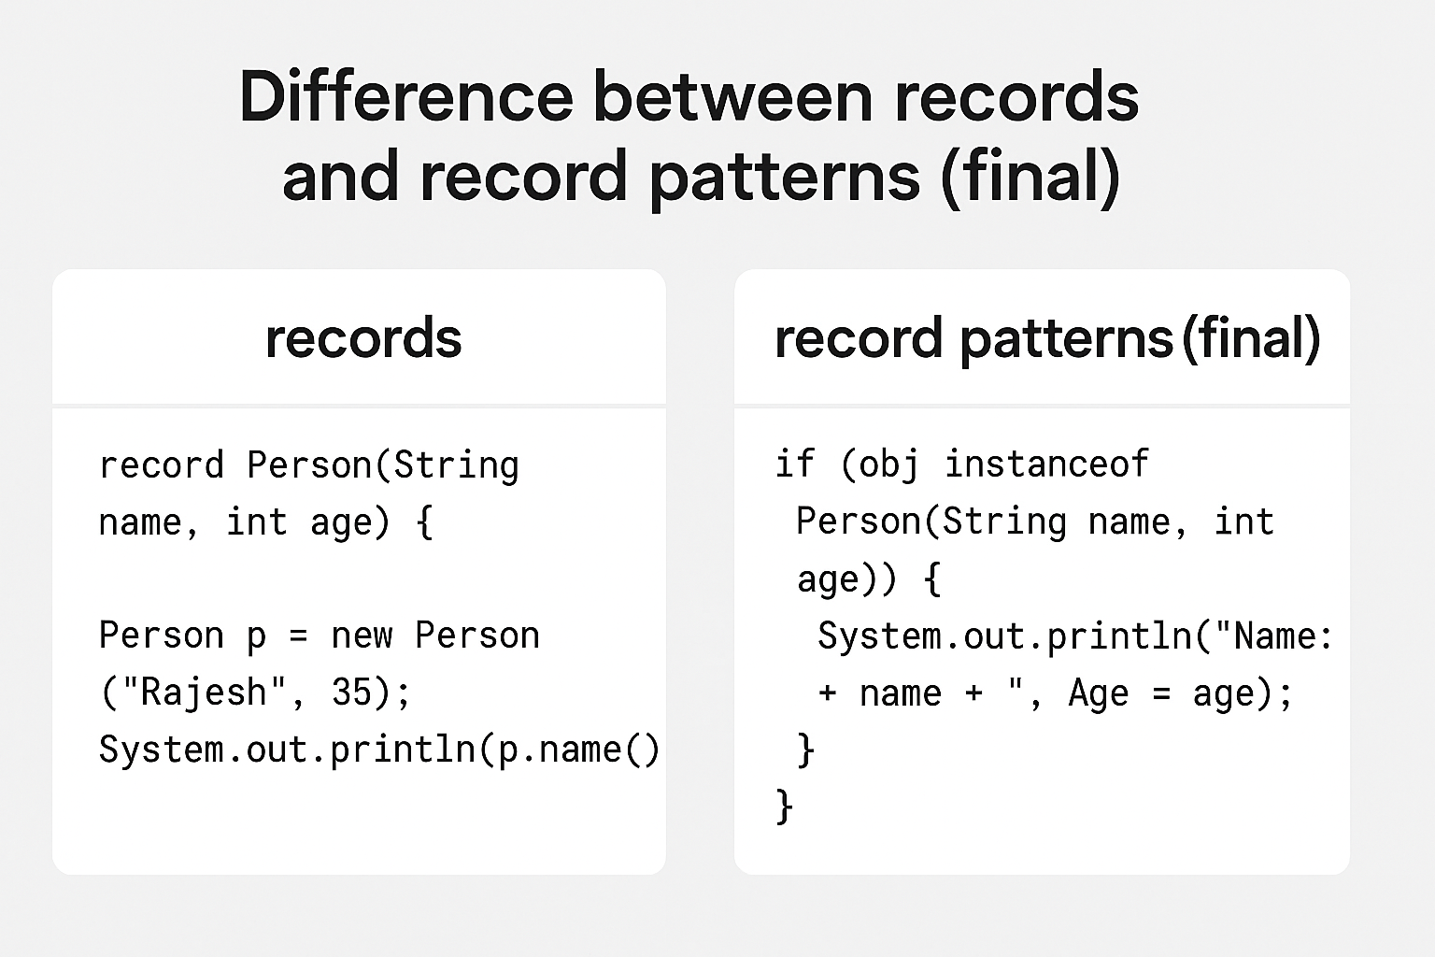

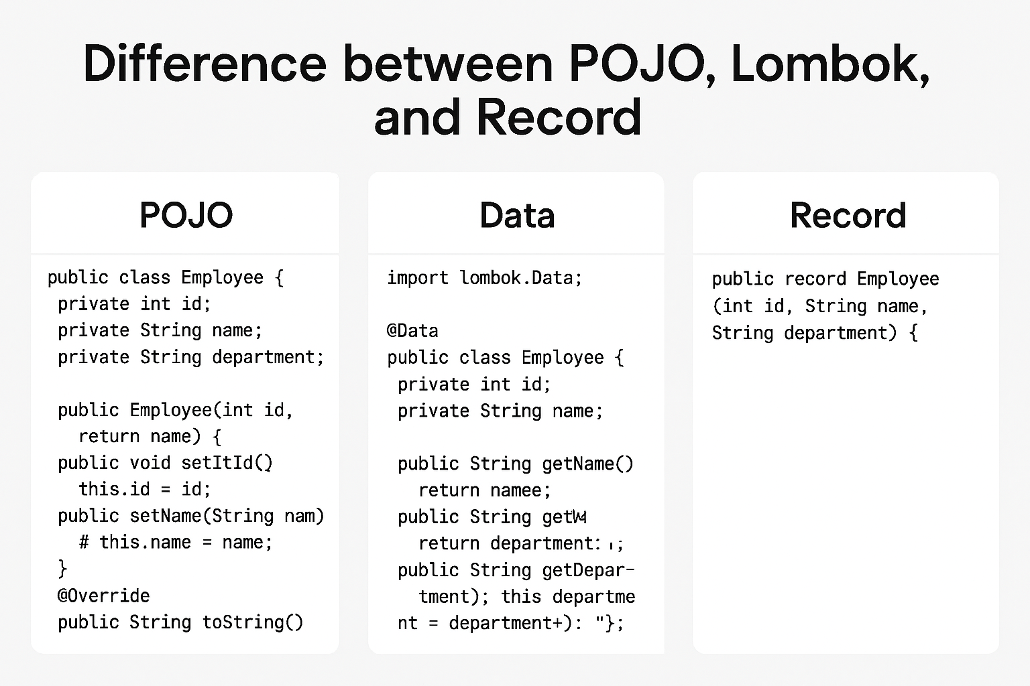

Here’s the **full Spring Boot REST API example using Java Records** (Controller + Service + DTO), extended for **GET and POST endpoints with validation**:

**✅ 1. Record DTO**

Java

// Employee.java

import jakarta.validation.constraints.NotBlank;

import jakarta.validation.constraints.Positive;

public record Employee(

@Positive(message = "ID must be positive") int id,

@NotBlank(message = "Name cannot be blank") String name,

@NotBlank(message = "Department cannot be blank") String department

) {}

Show more lines

**✅ 2. Service Layer**

Java

// EmployeeService.java

import org.springframework.stereotype.Service;

import java.util.ArrayList;

import java.util.List;

@Service

public class EmployeeService {

private final List<Employee> employees = new ArrayList<>();

public EmployeeService() {

employees.add(new Employee(101, "Rajesh", "IT"));

employees.add(new Employee(102, "Anita", "HR"));

}

public List<Employee> getAllEmployees() {

return employees;

}

public Employee addEmployee(Employee employee) {

employees.add(employee);

return employee;

}

}

Show more lines

**✅ 3. Controller**

Java

// EmployeeController.java

import org.springframework.web.bind.annotation.*;

import jakarta.validation.Valid;

import java.util.List;

@RestController

@RequestMapping("/api/employees")

public class EmployeeController {

private final EmployeeService employeeService;

public EmployeeController(EmployeeService employeeService) {

this.employeeService = employeeService;

}

@GetMapping

public List<Employee> getEmployees() {

return employeeService.getAllEmployees();

}

@PostMapping

public Employee createEmployee(@Valid @RequestBody Employee employee) {

return employeeService.addEmployee(employee);

}

}

Show more lines

**✅ Key Features**

✔ Uses **Java Records** for DTO  
✔ **Validation** with jakarta.validation annotations  
✔ **GET** and **POST** endpoints  
✔ Immutable data structure, no boilerplate

**********************************************************************************

* Virtual Threads (Final)

**Virtual Threads (Final)** in Java are part of **Project Loom**, introduced to simplify concurrency by providing lightweight threads that scale better than traditional platform threads.

**✅ What Are Virtual Threads?**

* Virtual threads are **lightweight threads** managed by the JVM, not the OS.
* They allow you to create **thousands or millions of threads** without exhausting system resources.
* Ideal for **I/O-bound tasks** like handling many concurrent requests.

**✅ Key Benefits**

* **Massive scalability**: Millions of threads possible.
* **Simpler concurrency model**: Same API as traditional threads.
* **Better resource utilization**: No heavy OS thread overhead.

**✅ Example: Using Virtual Threads**

Java

import java.util.concurrent.ExecutorService;

import java.util.concurrent.Executors;

public class VirtualThreadExample {

public static void main(String[] args) {

// Create an ExecutorService with virtual threads

try (ExecutorService executor = Executors.newVirtualThreadPerTaskExecutor()) {

for (int i = 1; i <= 10; i++) {

int taskId = i;

executor.submit(() -> {

System.out.println("Running task " + taskId + " on " + Thread.currentThread());

Thread.sleep(1000); // Simulate work

return taskId;

});

}

}

}

}

Show less

Code block expanded

**✅ How It Works**

* Executors.newVirtualThreadPerTaskExecutor() creates an executor that runs each task on a new virtual thread.
* Virtual threads use **continuations** internally, making them extremely lightweight.

**✅ When to Use**

* High-concurrency applications (e.g., web servers, microservices).
* I/O-heavy workloads (database calls, network requests).

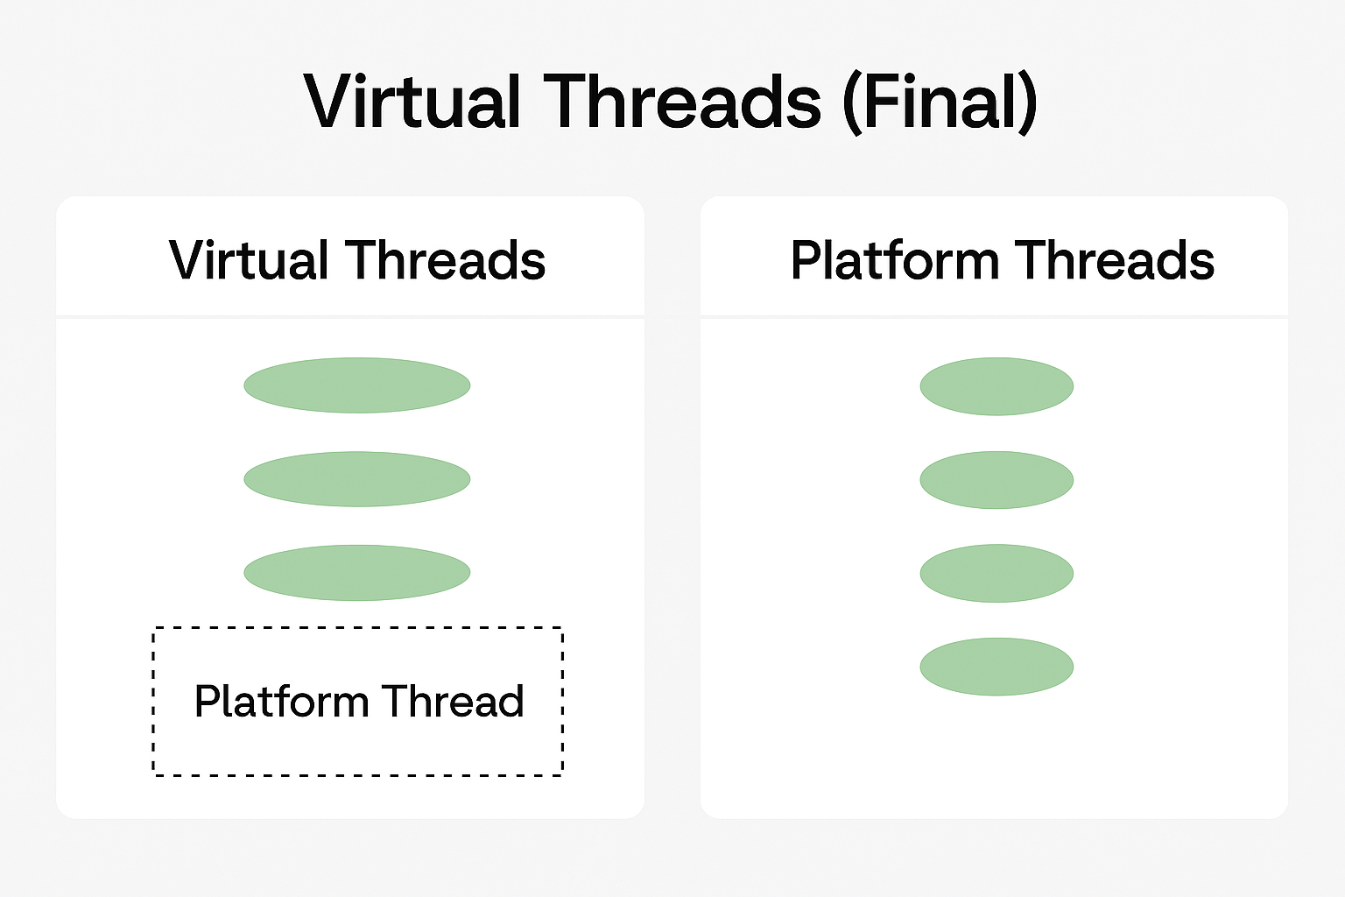

**********************************************************************************

**String Templates (Preview)**

Simplifies string interpolation.

String name = "Rajesh";

int age = 35;

String message = STR."Hello, \{name}. You are \{age} years old.";

System.out.println(message);

**4. Sequenced Collections**

Adds **ordered operations** to collections.

Java

SequencedCollection<String> list = new ArrayList<>();

list.addFirst("First");

list.addLast("Last");

System.out.println(list.getFirst()); // First

**Pattern Matching for Switch (Final)**

Cleaner type-based switch.

Java

static String format(Object obj) {

return switch (obj) {

case Integer i -> "Integer: " + i;

case String s -> "String: " + s;

default -> "Unknown";

};

}

Show more lines

**✅ 6. Vector API (Incubator)**

High-performance SIMD operations.

Java

import jdk.incubator.vector.*;

FloatVector vector = FloatVector.fromArray(FloatVector.SPECIES_256, new float[]{1,2,3,4}, 0);

FloatVector result = vector.add(vector);

System.out.println(result);

Show more lines

**✅ 7. Foreign Function & Memory API (Final)**

Interacts with native code and memory safely.

Java

import java.lang.foreign.*;

try (Arena arena = Arena.openConfined()) {

MemorySegment segment = arena.allocate(100);

segment.set(ValueLayout.JAVA_INT, 0, 42);

System.out.println(segment.get(ValueLayout.JAVA_INT, 0));

}

Show more lines

📌 **Java 21 is a big leap for performance and developer productivity**:

* Virtual Threads → Concurrency simplified.
* Record Patterns & Pattern Matching → Cleaner code.
* String Templates → Easier string handling.
* Memory & Vector APIs → High-performance computing.

**************************************************************

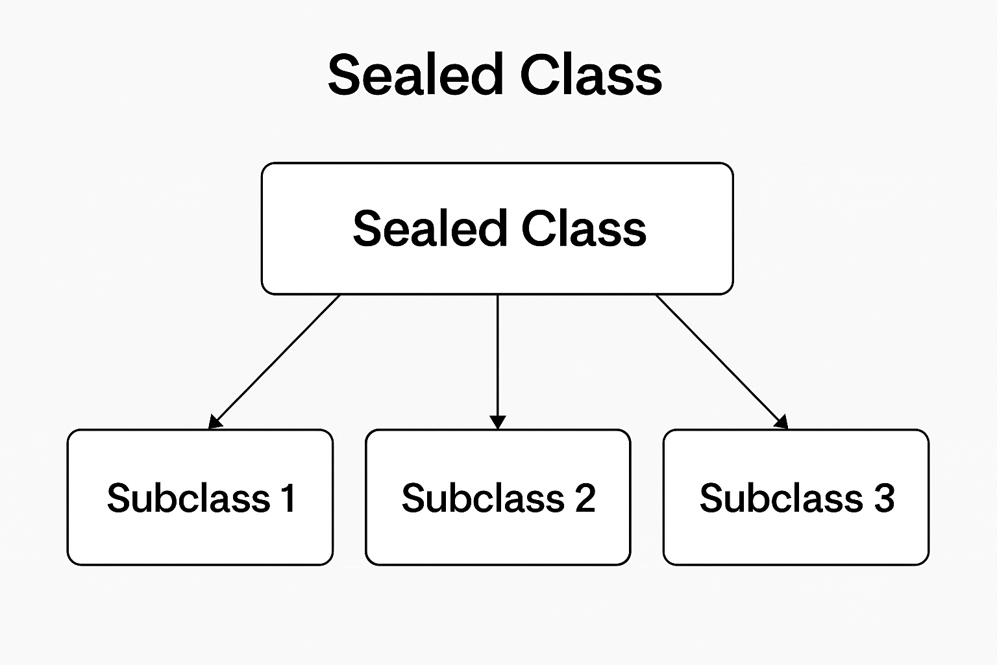

A **sealed class** in Java is a special type of class introduced in **Java 17** that restricts which other classes can extend or implement it. This feature is part of Java’s **pattern matching and type safety improvements**.

**✅ Key Characteristics**

* Declared with the sealed modifier.
* Must specify **permitted subclasses** using the permits clause.
* Permitted subclasses must be final, sealed, or non-sealed.

**✅ Why Sealed Classes?**

* Provides **controlled inheritance**.
* Improves **pattern matching** in switch statements.
* Enhances **security and maintainability** by limiting subclassing.

**✅ Example**

Java

sealed interface Shape permits Circle, Rectangle, Triangle {}

final class Circle implements Shape {

double radius;

Circle(double radius) { this.radius = radius; }

}

final class Rectangle implements Shape {

double length, width;

Rectangle(double length, double width) { this.length = length; this.width = width; }

}

final class Triangle implements Shape {

double base, height;

Triangle(double base, double height) { this.base = base; this.height = height; }

}

Show more lines

**✅ Usage with Pattern Matching**

Java

static double area(Shape shape) {

return switch (shape) {

case Circle c -> Math.PI * c.radius * c.radius;

case Rectangle r -> r.length * r.width;

case Triangle t -> 0.5 * t.base * t.height;

};

}

Show more lines

✔ **Benefits**:

* Compiler knows all possible subclasses → exhaustive switch checks.
* Prevents unwanted subclassing.